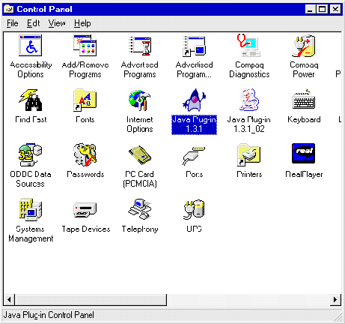Category: Error Message Creation Date: 2/25/2003 11:14 AM
Product: Dodge Plans CD
Keywords: Error, Java, FixedBPRDatabases
Document: 0000.doc

Why do I receive a Java.Lang.VerifyError using my old version of Dodge Plans ever since I have installed the New version?

After installing the new Dodge Plans CD program you may get a Java error when trying to open up the old Dodge Plans CD program:

Java.lang.VerifyError: (class: docsansm method: FixedBPRDatabases signature: (LBPRdb;LBPRdb;LBPRdb;)V) Illegal use of nonvirtual function call.

We have found this error to be caused by a newer version of Sun Java existing on the computer (version 1.3.1_02 found during testing). In control panel you will see more than one java Icon. Dodge Plans uses version 1.3.1.

Double-click on the Java 1.3.1_02 icon to open up the other Java Plug-in:
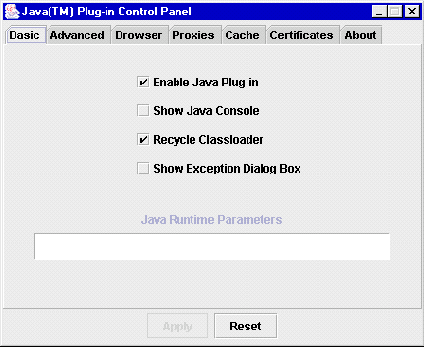

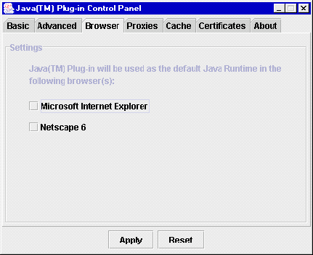Click on the Tab for Browser:

Make sure that no browser is selected. This will now allow you to run either version of the Dodge Plans CD program.

